

**DELTA Extractor  
  
Google Chrome Edition**

DELTA Extractor Installation

1. Download Selenium Basic, Chrome Driver and Delta Extractor file from link below:   
   [Selenium Basic, Chrome Driver & Delta Extractor for Chrome Link](https://github.com/SSImmukhtar/DELTA-Extractor.git)

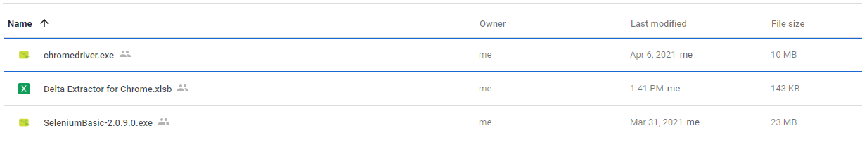

1. Run “Selenium Basic” installer
   1. Run installer.



* 1. Click “Run”

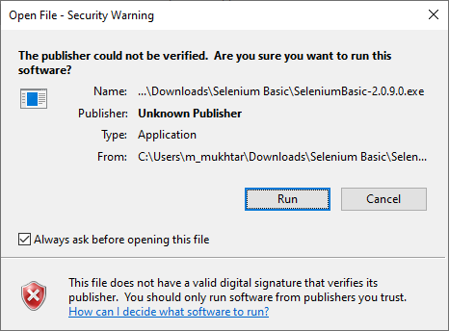

* 1. Click “Next”

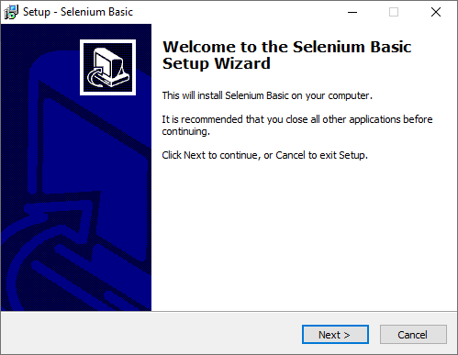

* 1. Select “I accept the agreement” and click “Next”

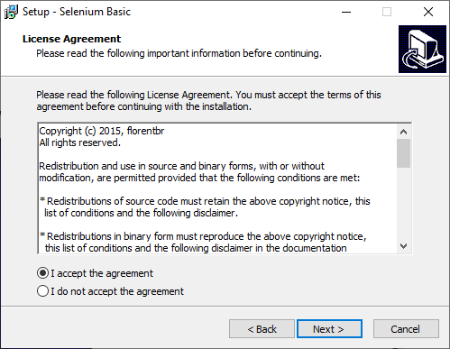

* 1. Select only “Templates and examples” and “Enhanced console runner for VBScript files”

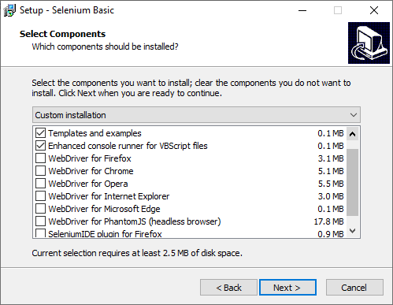

* 1. Click “Install”

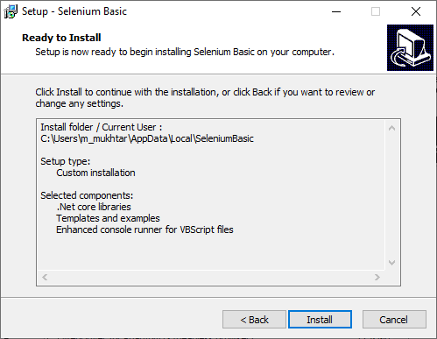

* 1. Wait until the installation complete and click “Finish”

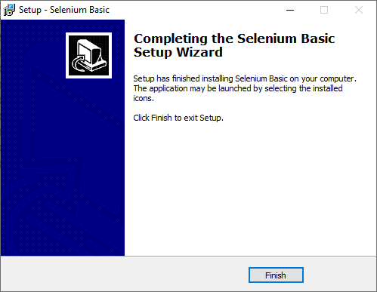

1. Placed “chromedriver” into Selenium folder path.   
   Example: ‘C:\Program Files\SeleniumBasic’

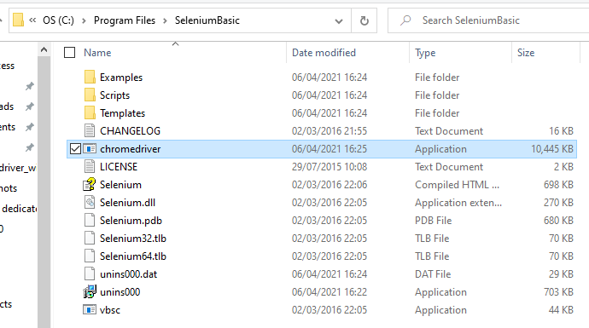

1. Placed the “Delta Extractor for Chrome” file onto your Desktop.